Mastering OOP and Modular Coding for MLOps (Day 3)

**1. Why OOP Matters in MLOps**

* **Modularity**: Break complex ML systems into reusable components
* **Encapsulation**: Protect sensitive data (API keys, credentials)
* **Maintainability**: Update components without breaking entire pipelines
* **Reproducibility**: Standardized interfaces for experiments
* **Collaboration**: Clear contracts between team members

*ML Impact*: 78% of production ML failures trace to non-modular code (McKinsey)

**2. Core OOP Concepts**

Diagram

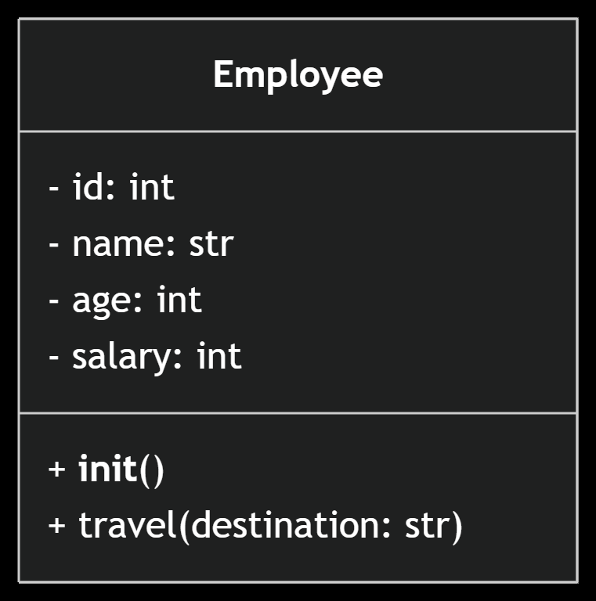

| **Concept** | **Definition** | **MLOps Application** |
| --- | --- | --- |
| **Class** | Blueprint for objects | DataPreprocessor, ModelTrainer |
| **Object** | Instance of a class | preprocessor = DataPreprocessor() |
| **Constructor (**__init__**)** | Initializes new objects | Set default hyperparameters |
| **Attributes** | Object state variables | model_version, feature_columns |
| **Methods** | Object behaviors | train(), evaluate(), deploy() |
| self | Current instance reference | Access attributes within methods |

**3. Modular Coding Principles**

**Problem**: Monolithic ML scripts (5000+ lines) that break with small changes  
**Solution**: Component-based architecture:

# project structure

ml_pipeline/

├── data_processing/

│ ├── __init__.py

│ ├── cleaner.py # DataCleaning class

│ └── featurizer.py # FeatureEngineer class

├── model_training/

│ ├── trainer.py # ModelTrainer class

│ └── validator.py # ModelValidator class

└── deployment/

└── api_handler.py # PredictionAPI class

**Key Benefits**:

* Test components independently
* Reuse feature engineering across projects
* Parallel development by teams

**4. Advanced OOP Techniques for ML**

**a. Inheritance for Model Versioning**

class BaseModel(ABC):

@abstractmethod

def train(self, data):

pass

class RandomForestModel(BaseModel):

def train(self, data):

print("Training Random Forest...")

class TransformerModel(BaseModel):

def train(self, data):

print("Training Transformer...")

**b. Encapsulation for Security**

class CredentialManager:

def __init__(self):

self.__api_key = os.getenv("API_KEY") # Private attribute

def deploy_model(self):

if self.__validate_key():

print("Deploying securely...")

**c. Polymorphism for Pipeline Flexibility**

def run_pipeline(processor: DataPreprocessor):

processed = processor.transform() # Works for any processor type

**5. Real-World MLOps Implementation**

**Modular Training Pipeline**:

# data_processing/pipeline.py

class DataPipeline:

def __init__(self, source):

self.raw_data = load_data(source)

def clean(self):

# Remove nulls, fix formats

return self

def featurize(self):

# Add new features

return self

# model_training/trainer.py

class ModelTrainer:

def __init__(self, pipeline):

self.data = pipeline.processed_data

def train(self):

# Training logic

return trained_model

# Usage

pipeline = DataPipeline("s3://data").clean().featurize()

trainer = ModelTrainer(pipeline)

model = trainer.train()

**6. Operator Overriding in ML (Advanced)**

Customize behavior for ML objects:

class ModelEvaluation:

def __init__(self, metrics):

self.metrics = metrics

def __add__(self, other):

"""Combine evaluation metrics"""

return ModelEvaluation({**self.metrics, **other.metrics})

def __str__(self):

return f"Metrics: {self.metrics}"

# Usage

eval1 = ModelEvaluation({"accuracy": 0.92})

eval2 = ModelEvaluation({"f1": 0.88})

combined = eval1 + eval2

print(combined) # Metrics: {'accuracy': 0.92, 'f1': 0.88}

**7. OOP Best Practices for MLOps**

1. **Single Responsibility Principle**  
   Each class does one thing (e.g., DataLoader only loads data)
2. **Type Hinting**

def predict(self, input: pd.DataFrame) -> np.ndarray:

1. **Docstrings for Documentation**

class FeatureEngineer:

"""Transforms raw data into ML features"""

1. **Private Members for Internal State**

self.__internal_cache = {} # Not accessible externally

1. **Error Handling with Exceptions**

class InvalidDataError(Exception):

pass

**8. Interview Prep: Key Questions**

1. **When to use classes vs functions?**  
   Use classes when managing state (e.g., model weights), functions for stateless operations
2. **How does**self**differ from**this**in other languages?**  
   Python requires explicit self, while Java/C++ use implicit this
3. **Why avoid global variables in classes?**  
   Breaks encapsulation and causes hidden dependencies
4. **What's the difference between**__init__**and**__new__**?**  
   __new__ creates the object, __init__ initializes it

**9. Pro Tips for Production ML**

* **Version Classes**: class DataPreprocessorV2(DataPreprocessor)
* **Lazy Loading**: Load heavy resources (models) only when needed
* **Decorators for Logging**:

def log_execution(func):

def wrapper(*args, **kwargs):

print(f"Executing {func.__name__}")

return func(*args, **kwargs)

return wrapper

class ModelTrainer:

@log_execution

def train(self):

...

**10. Further Learning**

* **Books**: *Clean Code in Python* (Mariano Anaya)
* **Courses**: [Python Design Patterns](https://refactoring.guru/design-patterns/python)
* **Tools**:
  + **Pylint**: Enforce OOP standards
  + **Mypy**: Static type checking
  + **Sphinx**: Auto-generate documentation

"Good OOP design is the difference between ML models that survive production and those that fail within weeks."  
– ML Engineering Lead, Google Cloud

Master these concepts to build ML systems that scale reliably from experimentation to production! 🚀